**PIZZA SALES SQL QUERIES**

**A. KPI’s**

**1.** **Total Revenue**

SELECT CAST(SUM([total_price]) AS DECIMAL(10,2)) AS Total_Revenue FROM [dbo].[Pizza_Sales]

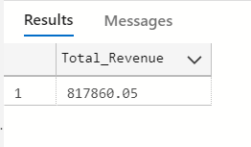

**2. Average Order Value**

SELECT CAST(CAST(SUM([total_price]) AS DECIMAL(10,2)) / CAST(COUNT(DISTINCT [order_id]) AS DECIMAL(10,2)) AS DECIMAL(10,2)) AS Avg_Order_Value FROM [dbo].[Pizza_Sales]

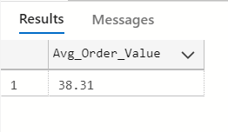

**3. Total Pizzas Sold**

SELECT SUM([quantity]) AS Total_Pizza_Sold FROM [dbo].[Pizza_Sales]

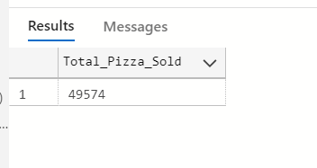

**4. Total Orders**

SELECT COUNT(DISTINCT [order_id]) AS Total_Orders FROM [dbo].[Pizza_Sales]

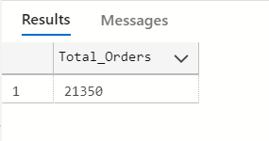

**5. Average Pizza’s Per Order**

SELECT CAST(CAST(SUM([quantity]) AS DECIMAL(10,2)) / CAST(COUNT(DISTINCT [order_id]) AS DECIMAL(10,2)) AS DECIMAL(10,2)) AS Avg_Pizza_Per_Order FROM [dbo].[Pizza_Sales]

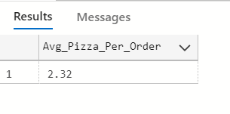

**B. Daily Trend for Total Orders**

SELECT DATENAME(DW, [order_date]) AS Order_day, COUNT(DISTINCT [order_id]) AS Total_Orders FROM [dbo].[Pizza_Sales]

GROUP BY DATENAME(DW, [order_date])

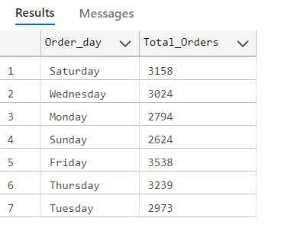

**C. Monthly Trend for Orders**

SELECT DATENAME(MONTH, [order_date]) AS Month_Name, COUNT(DISTINCT [order_id]) AS Total_Orders

FROM [dbo].[Pizza_Sales]

GROUP BY DATENAME(MONTH, [order_date])

ORDER BY Total_Orders DESC

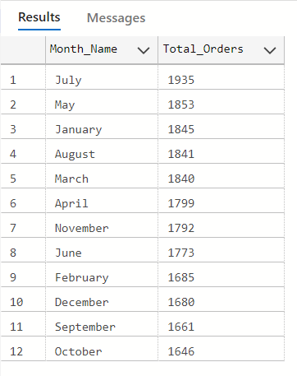

**D. % of Sales by Pizza Category**

SELECT [pizza_category], SUM([total_price]) AS Total_Sales, SUM([total_price]) * 100 / (SELECT SUM([total_price]) FROM [dbo].[Pizza_Sales]) AS PCT_Total_Sales

FROM [dbo].[Pizza_Sales]

GROUP BY [pizza_category]

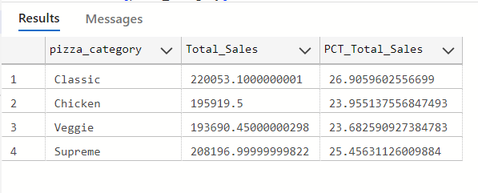

--USING FILTER

SELECT [pizza_category], SUM([total_price]) AS Total_Sales, SUM([total_price]) * 100 /

(SELECT SUM([total_price]) FROM [dbo].[Pizza_Sales] WHERE MONTH([order_date]) = 1) AS PCT_Total_Sales

FROM [dbo].[Pizza_Sales]

WHERE MONTH([order_date]) = 1

GROUP BY [pizza_category]

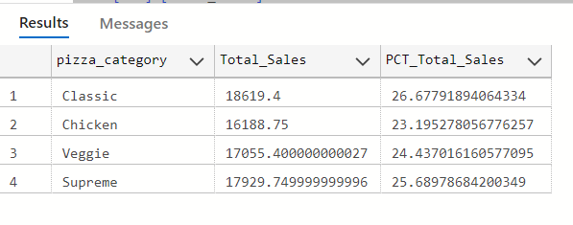

**E. % of Sales by Pizza Size**

SELECT [pizza_size], CAST(SUM([total_price])AS DECIMAL(10,2)) AS Total_Revenue, CAST(SUM([total_price]) * 100 / (SELECT SUM([total_price]) FROM [dbo].[Pizza_Sales]) AS DECIMAL(10,2)) AS PCT

FROM [dbo].[Pizza_Sales]

GROUP BY [pizza_size]

ORDER BY [pizza_size]

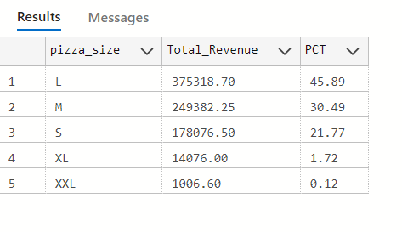

**F. Total Pizzas Sold by Pizza Category**

SELECT [pizza_category], SUM([quantity]) AS Total_Quantity_Sold

FROM [dbo].[Pizza_Sales]

WHERE MONTH([order_date]) = 2

GROUP BY [pizza_category]

ORDER BY Total_Quantity_Sold DESC

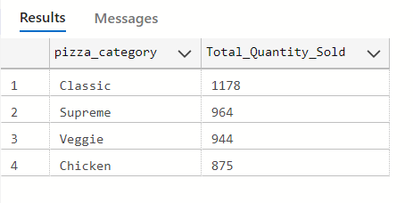

**G. Top 5 Pizzas by Revenue, Quantity and Total Orders**

--By Revenue

SELECT TOP 5 [pizza_name], SUM([total_price]) AS Total_Revenue

FROM [dbo].[Pizza_Sales]

GROUP BY [pizza_name]

ORDER BY Total_Revenue DESC

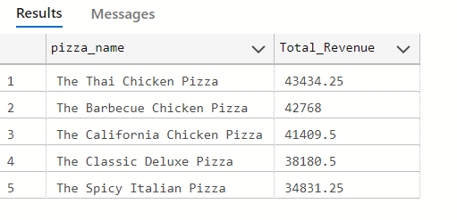

--By Quantity

SELECT TOP 5 [pizza_name], SUM([quantity]) AS Total_Pizza_Sold

FROM [dbo].[Pizza_Sales]

GROUP BY [pizza_name]

ORDER BY Total_Pizza_Sold DESC

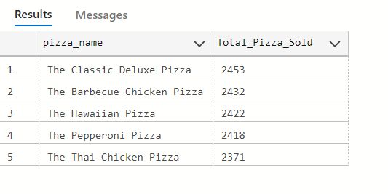

--By Total Orders

SELECT TOP 5 [pizza_name], COUNT(DISTINCT [order_id]) AS Total_Orders

FROM [dbo].[Pizza_Sales]

GROUP BY [pizza_name]

ORDER BY Total_Orders DESC

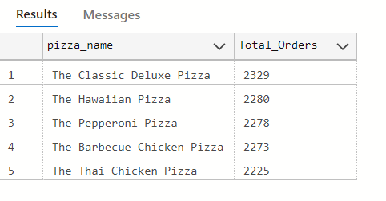

**H. Bottom 5 Pizzas by Revenue, Quantity and Total Orders**

--By Revenue

SELECT TOP 5 [pizza_name], SUM([total_price]) AS Total_Revenue

FROM [dbo].[Pizza_Sales]

GROUP BY [pizza_name]

ORDER BY Total_Revenue ASC

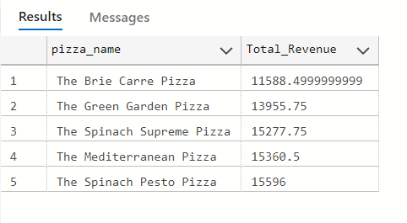

--By Quantity

SELECT TOP 5 [pizza_name], SUM([quantity]) AS Total_Pizza_Sold

FROM [dbo].[Pizza_Sales]

GROUP BY [pizza_name]

ORDER BY Total_Pizza_Sold ASC

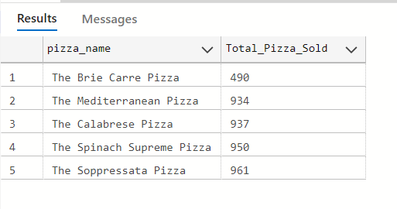

--By Total Orders

SELECT TOP 5 [pizza_name], COUNT(DISTINCT [order_id]) AS Total_Orders

FROM [dbo].[Pizza_Sales]

GROUP BY [pizza_name]

ORDER BY Total_Orders ASC

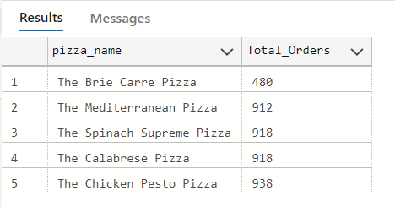

**NOTE**

If you want to apply the pizza_category or pizza_size filters to the above queries you can use the WHERE clause. Follow some of the below examples

SELECT TOP 5 [pizza_name], COUNT(DISTINCT [order_id]) AS Total_Orders

FROM [dbo].[Pizza_Sales]

WHERE [pizza_category] = 'Classic'

GROUP BY [pizza_name]

ORDER BY Total_Orders ASC

